**Assignment 2 Use-Case Unit Converter**

Case 1: The user enters a degree in the Fahrenheit or Celsius text box. Then the app converts that into Celsius if they typed in the Fahrenheit text box or converts it into Fahrenheit if they typed into the Celsius text box.

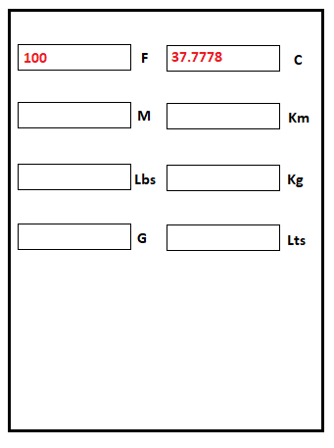

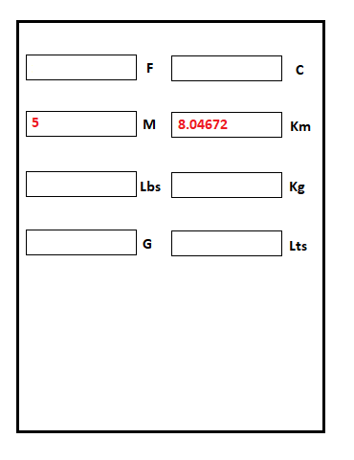Case 2: The user enters a number of miles in the Miles or Kilometers text box. Then the app converts that into Kilometers if they typed in the Miles text box or converts it into miles if they typed into the Kilometers text box.

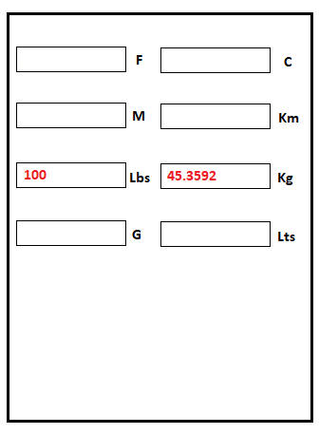Case 3: The user enters a weight in the Pounds or Kilograms text box. Then the app converts that into Kilograms if they typed in the Pounds text box or converts it into Pounds if they typed into the Kilograms text box.

Case 4: The user enters a number in the Gallons or Liters text box. Then the app converts that into Liters if they typed in the Gallons text box or converts it into Gallons if they typed into the Liters text box.

